HOW TO USE “CARTS” MIMIC (ON BOLTS)

As of March 2023, CARTS MIMIC was tested on an older FLAIR Version 6.43.
PLEASE CHECK YOUR VERSION OF FLAIR / FLAIR CLASSIC FOR FUNCTIONALITY.
This allows a HERO TT move to be run and the PAN / TILT AXES adjusted manually “live” using a hand controller and then this new move is recorded in mimic and can be saved and replayed as needed.
You will need an RT type rootbox connected to FLAIR and manual PAN BAR / MIMIC WHEELS.
Note that you do not use the “SHOW MIMIC” axes selector that is normally used.
- Programme the Hero TT move and save it as normal.
- Connect the PAN BAR / MIMIC handwheels to the RT device.
- Select SETTINGS MISC CART CONTROL LIMITS and select “OFF”… This will ignore any Carts world limits that might stop the axes working as you use them, so be cautious.
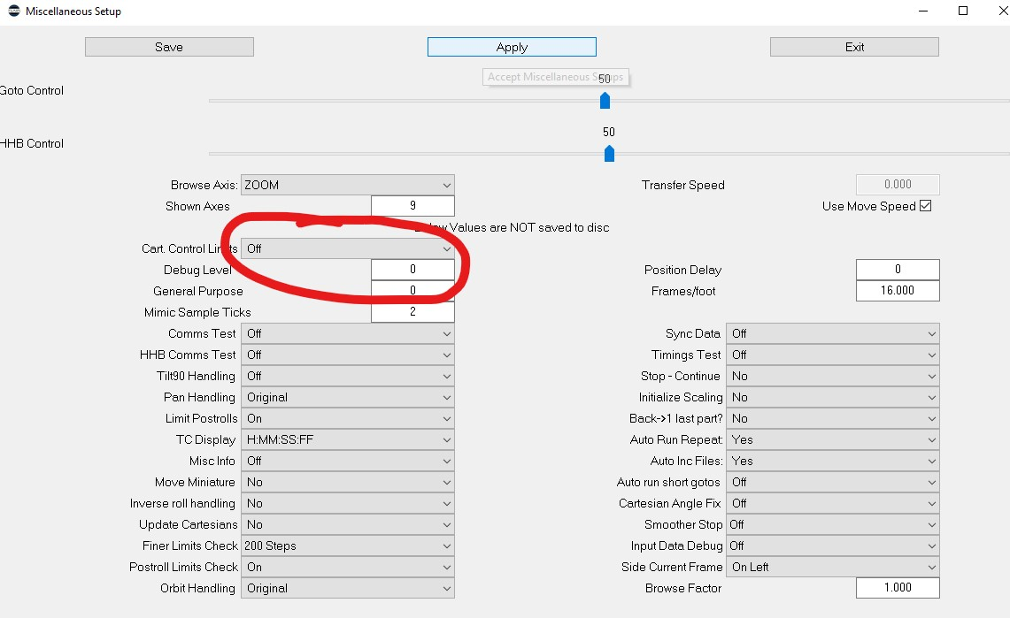
- Change the TT mode to “PAN & TILT” tracking.
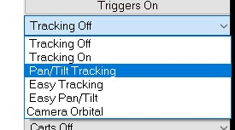
- Select SETUPS CARTS SETUP PAN and select the MIMIC port associated with the PanBar / handwheel that you need to control the PAN (normally RT MIMIC 1), then, select “ENCODER POS” and note the scaling number (normally 1)

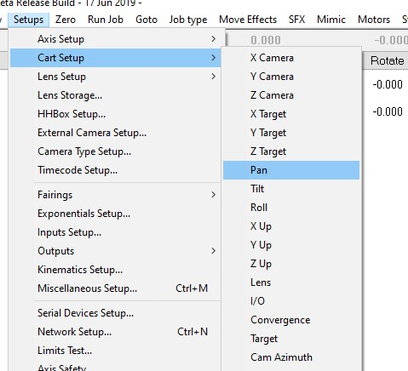

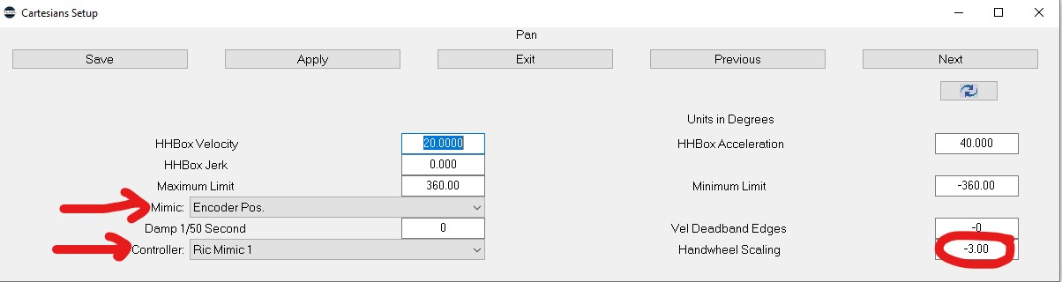
- Click on “APPLY”
- Do the same for TILT but select the other MIMIC port for the TILT (Normally RT MIMIC 2).
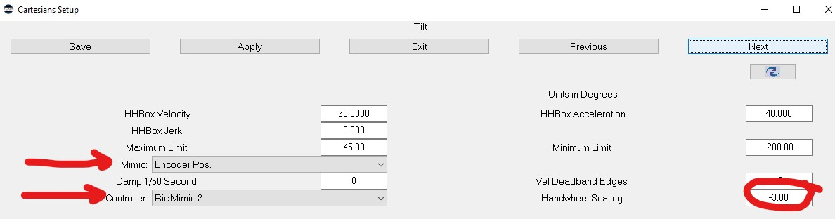
- Click on “APPLY”
- Select MIMIC CARTS MIMIC and tick PAN “ADD” and TILT “ADD”.

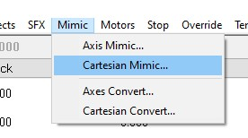

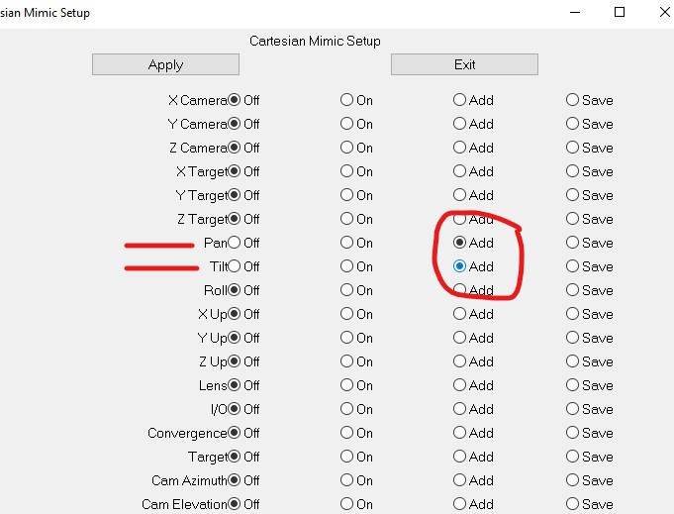
- Click on “MIMIC LEARN” and “ROBOT FAST” and then “FWD RUN”… you should get an “OVERWRITE MIMIC?” box appear but it will be a larger box than usual with a gap in the middle…. This is normal and is a good sign that the CARTS MIMIC mode is selected.
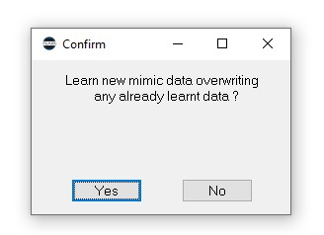
- Run the move and MIMIC the axes to follow the action as required.
- Save the move in the normal way. When replaying the move, it may give some speed or accel warnings. Check the graphs and run with caution.
- Return settings to normal after MIMIC has finished so that they are correct and limits will be returned to normal. The easiest way to do this is to read in the HERO job as before and use this as the base for the new move.

